A000-Asia-China-Hongshan-Scoop-Jade-4700 BCE

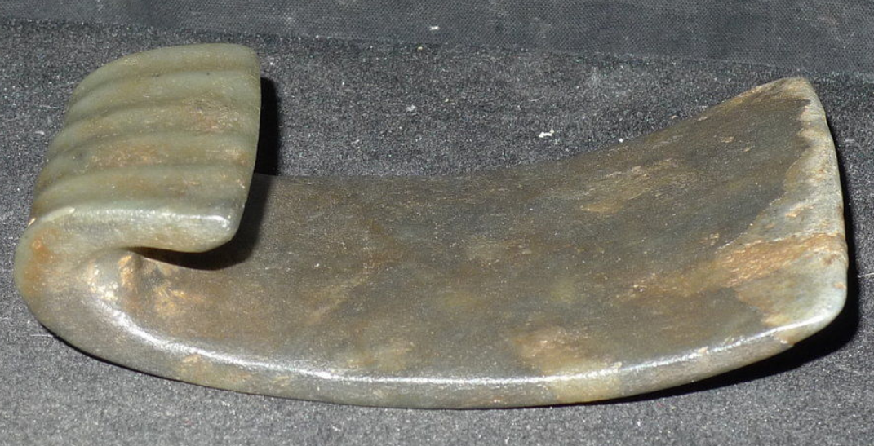 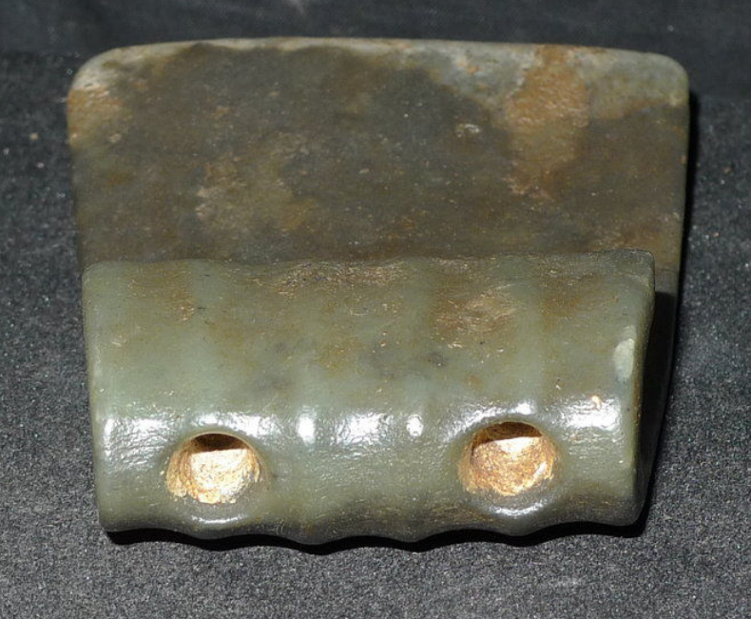 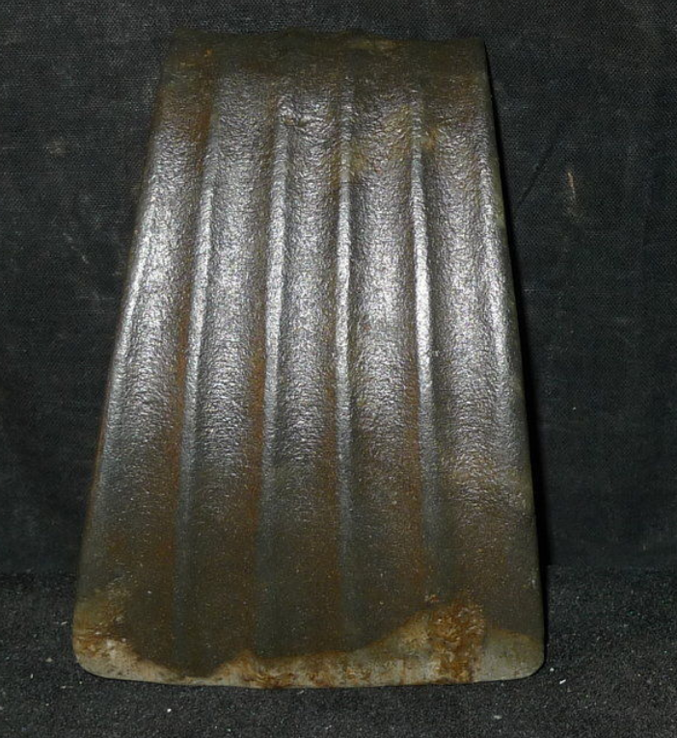

**Case No.: 5**

**Accession No.**

**Formal Label:** China-Hongshan-Scoop-Jade-4700 BCE

**Display Description: This enigmatic jade object suggests a scoop. It has a fine patina suggesting use wear and it has been decorated with five corrugations. Two hole at the point where it curves back on itself suggests its deployment was as an appliqué.**

**LC Classification:**

**Date or Time Horizon:**

**Geographical Area:**

**Map:**

**GPS coordinates:**

**Cultural Affiliation:**

**Media:**

**Dimensions:**

**Weight:**

**Condition:**

**Provenance:**

**Discussion:**

**References:**